

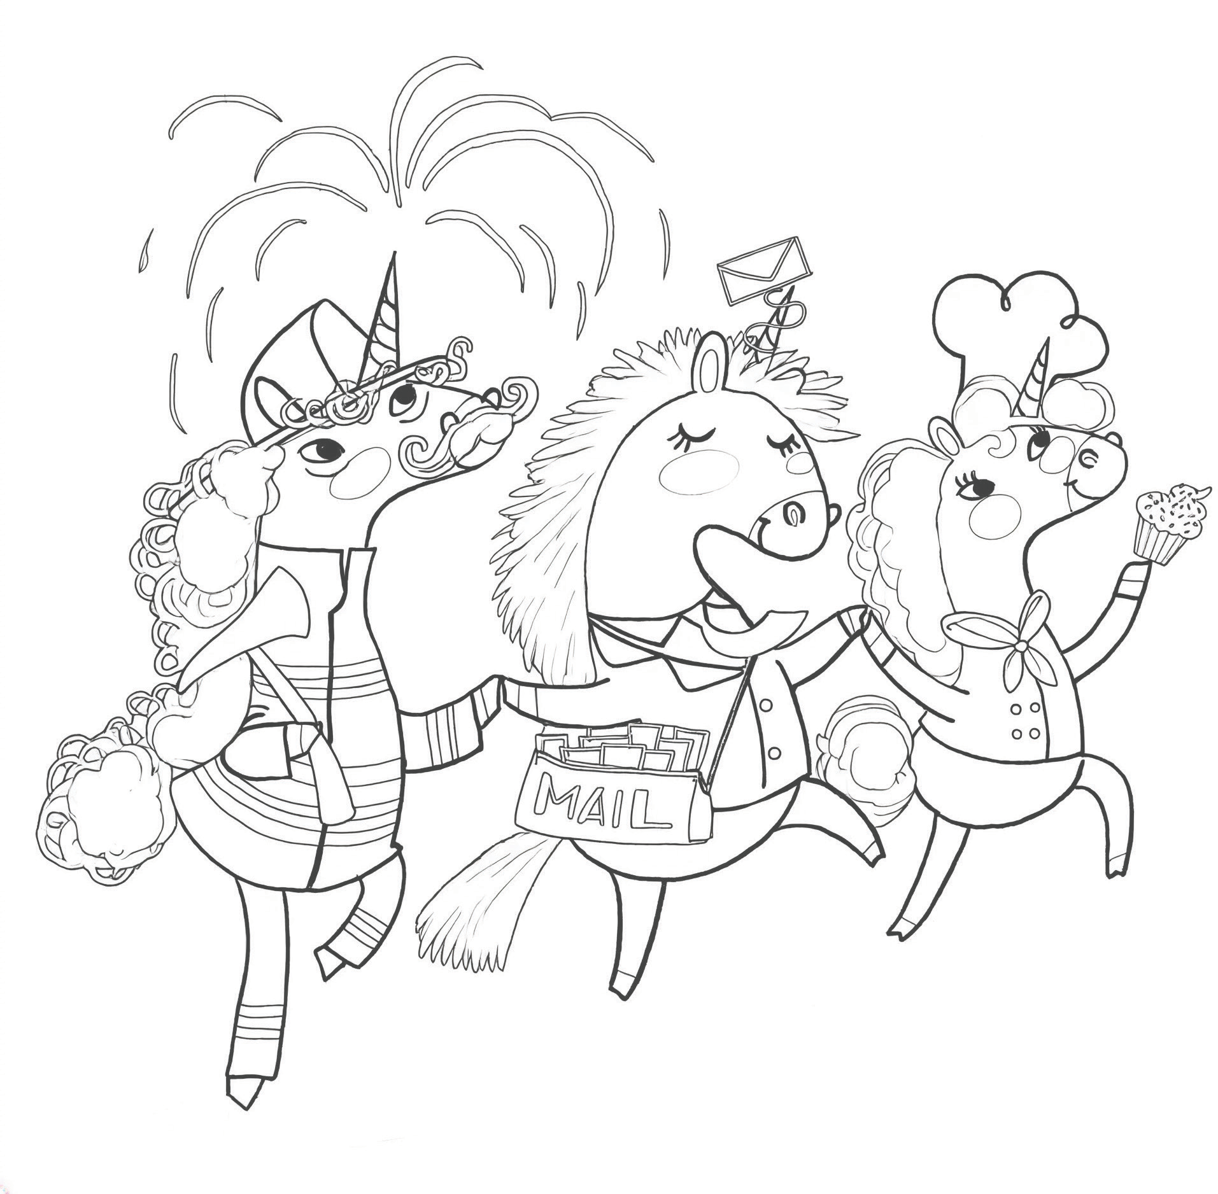
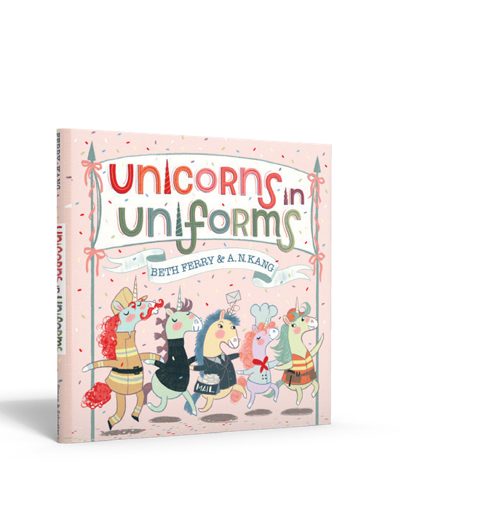
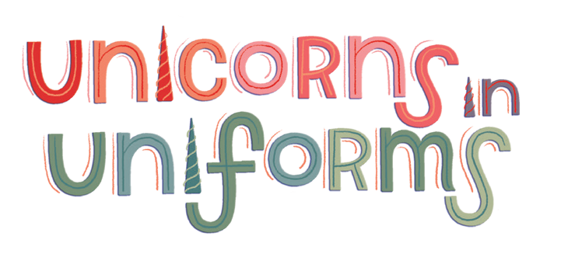

Color Me In!

By BETH FERRY
Illustrations © 2026 by A. N. Kang
Illustrated by A. N. KANG REPR ODUCIBLE

Mail Carrier

Farmer

Dancer

Music DJ

Doctor


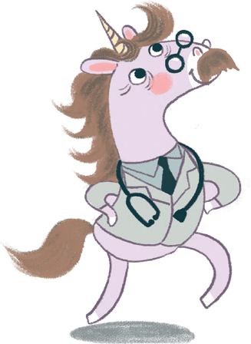
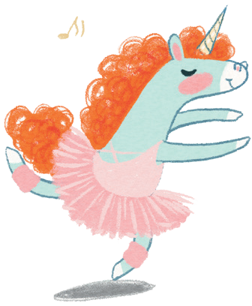
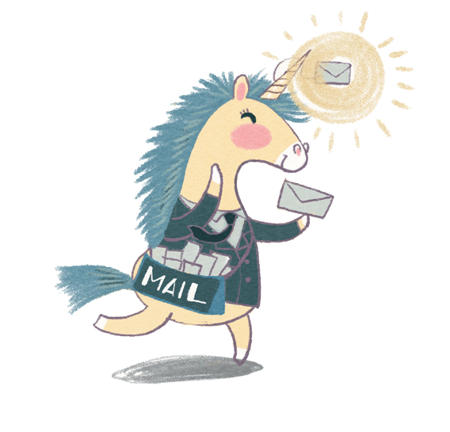
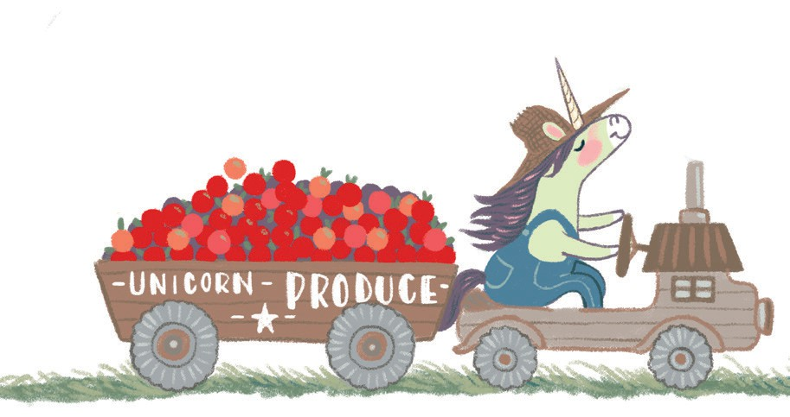
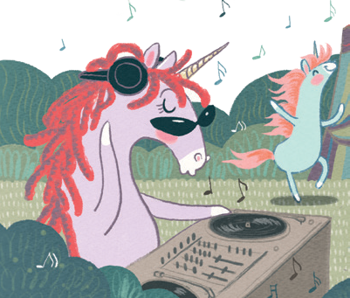
By BETH FERRY
Match the Unicorn to their Uniform!
Draw a line to match the correct unicorn with their job.
Illustrations © 2026 by A. N. Kang
Illustrated by A. N. KANG

REPR ODUCIBLE

